CURRICULAM VITAE

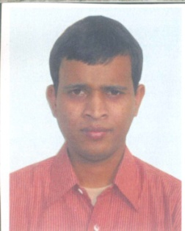
Bholanath Mandal
Assistant Professor
Department of History
Barasat College
Barasat, North 24 Parganas, kolkata-700126, WB
E-mail Id- bholaju@gmail.com

Education Qualification:
M.A in History, M. Phil, Ph. D

Specialization:
Ancient Indian History

Communication Skill:
Bengali and English

